

**Chemistry Lab Simulation**

**By:**

101832

099972

An Information Systems Proposal submitted to the Faculty of Information Technology in partial fulfilment of the requirements for the Bachelor of a Degree in Informatics and Computer Science

31-Aug-2018

# Declaration and Approval

We declare that this project has not been submitted to Strathmore University or any other university for the award of a degree in Informatics and Computer Science or any other degree

101832:

Sign: ________________________ Date: ________________________

099972:

Sign: ________________________ Date: ________________________

Sharon Mugambi:

Sign: ________________________ Date: ________________________

# Abstract

Laboratory practicals especially in Chemistry, has traditionally been confined to being performed within the school environment specifically, inside a laboratory. The laboratory equipment and procedures also has limited access by the students. Students are therefore not able to conduct experiments at their own convenient time.

The laboratory equipment provided by the schools may not be enough for all the students especially in schools that have a high number of students. The equipment and chemicals may also not be affordable by some schools. Due to the high number of student in some schools, teachers find it difficult to keep track of the performance of their students especially in Chemistry practicals.

The proposed solution is to create an online platform that simulates a Chemistry laboratory and makes it simple and efficient for students to perform experiments. Teachers will also monitor how the experiments are being conducted by their students and be able to identify the ones who need extra help in performing the experiments.

The software development methodology to be used is prototyping. This methodology is important in creating working models of the potential system. Most of the data collected is from observation and from online sources.

**Table of Contents**

Declaration and Approval ii

Abstract iii

List of Figures vi

List of Tables vii

Chapter 1: Introduction 1

1.1 Background 1

1.2 Problem Statement 2

1.3 Aim 2

1.3.1 Specific Objectives 2

1.3.2 Research Questions 2

1.4 Justification 3

1.5 Scope and Limitations 3

Chapter 2: Literature Review 4

2.1 Introduction 4

2.2 Challenges Students Face with the current systems 4

2.3 Current Technologies used in the area 4

2.3.1 PhET Interactive Simulations Technology 4

2.3.2 ChemCollective Technology 6

2.3.3 Virtual Chemistry Lab Technology 7

2.4 Existing Challenges in the use of the current systems 8

2.5 Gaps in the existing systems 9

2.6 Conceptual Framework 9

Chapter 3: Development Methodology 11

3.1 Introduction 11

3.2 Software Development Methodology 11

3.3 System Analysis 12

3.3.1 Functional requirements 12

3.3.2 Non-Functional requirements 13

3.3.3 System Narrative 13

3.4 System Design 14

3.4.1 Use Case Diagram 14

3.4.2 DFD (Up to level 1) 15

3.4.3 Entity Relationship Diagram 16

3.4.4 Database Schema 17

3.5 System Development Tools and Techniques 18

3.5.1 Visual Studio Code 18

3.5.2 JavaScript 18

3.5.3 HTML 18

3.5.4 CSS 18

3.5.5 PHP 18

3.5.6 Bootstrap 18

3.6 Deliverables 18

3.6.1 Student’s Module 18

3.6.2 Teacher’s Module 19

References 19

Appendices 22

Appendix A: GANTT Chart 22

# List of Figures

Figure 2.1 Variety of math and science options 6

Figure 2.2 Simulation of pH Scale 7

Figure 2.3 Conduction of a Concentration Experiment 8

Figure 2.4 View of Lab 9

Figure 2.5 Teacher’s Module Framework 11

Figure 2.6 Student’s Module Framework 12

Figure 3.1 Prototyping Model 14

Figure 3.2 Use Case Diagram 17

Figure 3.3 Context Level Diagram 18

Figure 3.4 Data Flow Diagram 18

Figure 3.5 Entity Relationship Diagram 19

Figure 3.6 Database Schema 20

# List of Tables

Table 1 Project Timeline 21

# Chapter 1: Introduction

## Background

Virtual laboratories are computer simulation-based environments used to interactively design and conduct controlled experiments (Gomes & Bogosyan, 2009). The laboratories can be reached through any computer network. The development of virtual laboratories is an interesting alternative to professional education as well as career development in several areas of knowledge. Interactive learning environment by using animations and simulations for abstract topics, where students become active in their learning, provide opportunities for students to construct and understand difficult concepts more easily.

The current curriculum in Kenya (8-4-4) includes a number of science subjects like Chemistry, Biology and Physics. In these science subjects, laboratories perform an important role in students’ learning enhancement, particularly in Chemistry education (Josephsen & Kristensen, 2006). Students take more interest in learning by performing and observing the experiments in the Chemistry laboratory which improves and consolidates their learning. The conduction of laboratory practicals, especially in Kenyan High Schools, has traditionally been confined to the school environment specifically, inside a laboratory. The laboratory equipment is also confined from the students. Students are therefore denied the chance to practice performing experiments on their own despite laboratory practicals having a central role in their performance.

The current lab sessions have a tutor-led introduction and practical demonstration of the procedures to be carried out (De Jong, Linn, & Zacharia, 2013). Students are then assigned to small groups to work in at various workstations with the guide of practical workbooks. Ideally, the tutor’s subsequent support would be light-touch. Unfortunately, the students are likely to be disengaged from the demonstrations and struggle with the procedures even when given the instructions in their workbooks.

All these challenges contribute to the average performance of students in Chemistry and the lack of enough practical skills in high school graduates. In this context, appropriate simulations and applications based on simulations increase the learning speed and curve by allowing students to express their real reactions easily (Kennepohl, 2001) thus improving one’s grades impeccably.

There is no current system in Kenya that can simulate the lab processes as conducted in accordance to the Kenyan education system. The available IT approaches to learning are the use of audio-visual equipment, which have a limited success in impacting knowledge to the students since there is lack of hands on approach. Therefore, virtual labs are vital in the development of academic achievement, providing awareness of scientific concepts and modifying misconceptions (Radhamani et al., 2014).

## Problem Statement

High school students in Kenya are confined to performing their Chemistry practicals within the school and under direct supervision inside a laboratory. This limits the students from improving their practical skills since they do not have direct access to the laboratory equipment when they might need them to practise on their own. The learning process of being confined to a classroom environment also becomes monotonous to the students and they can easily lose concentration (Tüysüz, 2010).

Sometimes the schools try to provide the laboratory equipment but due to the high number of students in their schools, some students may never get an opportunity to perform the experiments on their own since they are forced to share the few available equipment. Due to the high number of students in a class, it is also difficult for teachers to keep track of their students during experiments since they cannot identify the ones who require further assistance in the experiments. The schools also incur high costs while acquiring the laboratory equipment and chemicals for all their students (Oloruntegbe & Alam, 2010).

## 1.3 Aim

To develop a web application that will assist high school students and teachers to conduct Chemistry practicals efficiently.

### 1.3.1 Specific Objectives

1. To investigate the challenges encountered by students and teachers while conducting Chemistry practicals.
2. To analyse existing laboratory simulation software
3. To design, develop and test an application that will assist high school students and teachers conduct Chemistry practicals efficiently.

### 1.3.2 Research Questions

1. What challenges are faced by students and teachers while conducting Chemistry practicals?
2. What are the existing laboratory simulation software?
3. How are laboratory simulation software designed, developed and tested to aid in revision process?

## 1.4 Justification

Several studies in the past have shown that virtual laboratory effectively improve students achievement in Chemistry (Omilani Nathaniel, Rose, & Abubakar, 2007). This project will help schools to minimize on their cost of lab chemicals and equipment since they will all be available virtually and their students can understand the chemical processes easily. The learning objects in the simulated environment are reusable hence forming the basis of more enquiry-based laboratory learning (Carnevale, 2003). Every student will also have a chance to perform the experiments on their own and understand the various chemical reactions that take place. Students will also not need to rely on the availability of a school and a laboratory in order to perform an experiment.

Teachers will also be able to assign various tasks and be able to monitor the progress of their students and identify the ones having a hard time to perform the experiments in order to give more attention to them. This leads to a more efficient learning process where the teachers have direct interaction with the students and are able to identify their weaknesses (Corter, Nickerson, Esche, & Chassapis, 2004).

The introduction of lab-simulated practicals in the University of the West of England, Bristol, saw a massive improvement in the performance of the students in practicals. The students claimed they could understand the topics better and the physical processes taking place during the experiments. A similar system with an added functionality of teacher supervision can also be implemented in Kenyan schools and with no doubt, the performance of high school students in Chemistry will improve.

## 1.5 Scope and Limitations

The project targets high school students and teachers under the current education system in Kenya (8-4-4), specifically Chemistry as a subject and the practicals conducted within it subject.

The access of internet and electricity could be a challenge to some of the potential beneficiaries of the system. Prior knowledge in Chemistry is required in order to use the system. This might discourage new users in the field of Chemistry from using the system.

Some people will vastly prefer in-person learning to digital learning. Some tutors and students may be uncomfortable with the idea of either delivering or engaging with a course that is taught entirely from a virtual classroom (Nedic, Machotka, & Nafalski, 2003).

# Chapter 2: Literature Review

## 2.1 Introduction

The bulk of this chapter consists of an overview and analysis of existing technologies used to implement computer simulated Chemistry lab experiments. Besides that, it also evaluates the challenges students face with the existing systems. Finally, this chapter investigates the gaps in the existing simulation applications.

## 2.2 Challenges Students Face with the current systems

The current procedure in performing laboratory practicals is within a school compound and inside a laboratory. Student are therefore denied the chance to conduct their practicals beyond the classroom level.

In the current system it’s also difficult for teachers to keep track of the performance of their students in conducting practicals. This is due to the high number of students in some schools which makes it difficult for teachers to keep track of each student.

## 2.3 Current Technologies used in the area

In order to conceptualize and build the project framework, surveys from different sources of information were taken. There are multiple systems which allow students to conduct simulated laboratory experiments with the use of computers. Students appreciate the instant feedback, flexible access, and repeatability of the experiments. Moreover, they are granted access to cutting-edge technology that night not otherwise be available. In order to find the existing literature, the main area of focus was on three simulation systems: PhET Interactive Simulations, ChemCollective and Virtual Chemistry Lab.

### 2.3.1 PhET Interactive Simulations Technology

Founded in 2002 at the University of Colorado Boulder, this system creates interactive mathematics and science simulations. It is available for free on the website but for the application one needs to purchase it from Google Playstore for only 99¢ (100 Ksh). The app can be used in the classroom, at home and even offline.

The simulations are written in Java and most of them are in HTML5. They can run online or be downloaded for later use. More simulations are added as they are developed, and currently the website has over 134 different simulations, encompassing Physics, Biology, Chemistry, Earth Science, and Math, at all different grade levels.

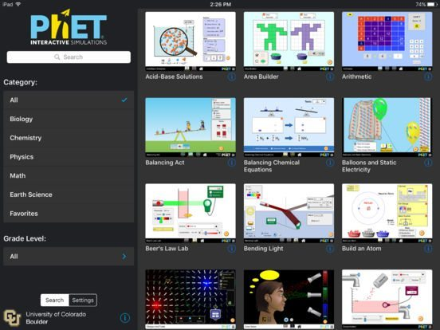

Figure 2.1 Variety of math and science options (Bristol, 2016)

One can take a look at the simulations by subject or grade level, view simulations marked as your favorites or search by keyword. Tapping the “i” next to each simulation displays a brief description and which topic it covers.

To help students engage in science and mathematics, PhET simulations are developed using concise design principles such as use of multiple representations e.g. object motion, graphs etc., interactivity between the user and the system components.

Several tools in the simulations provide an interactive experience: click and drag to interact with simulation features, use of sliders to increase and decrease parameters, options with radio buttons, taking if measurements with various instruments – rulers, thermometers, stopwatches.

As users interact with these tools, they get immediate feedback about the effect of the changes they made. This allows them to investigate cause-and-effect relationships and answer scientific questions through exploration of the simulation.

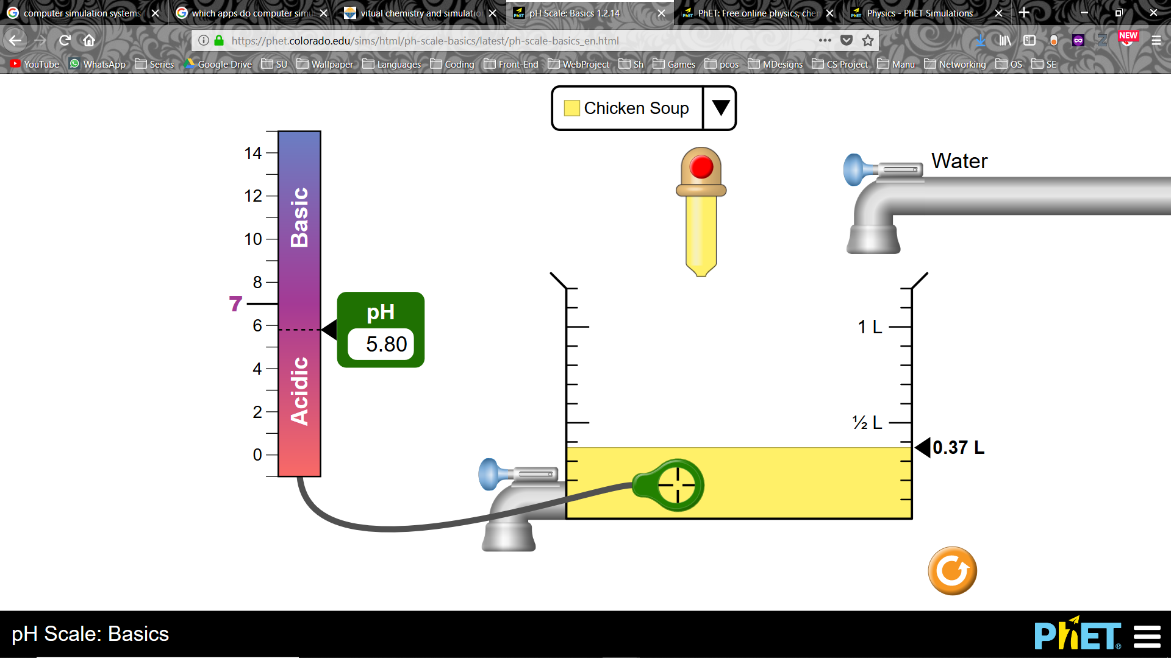

Figure 2.2 Simulation of pH Scale (Wieman, Adams, & Perkins, 2008)

### 2.3.2 ChemCollective Technology

ChemCollective is a collection of virtual labs, scenario-based learning activities, tutorials and concept tests for Chemistry. Teachers can use this content for their own laboratories, for alternatives to textbooks and for individual or team based experiments. It offers online simulations of Chemistry labs designed to allow learners to select from hundreds of standard reagents and manipulate them as within a real lab, but without the added cost of real equipment and potential hazards.

Within virtual labs, students have activities to set up practical equipment. The workbench allows students to complete titrations, make standard solutions and carry out many more protocols. The major advantage of the virtual lab is that students are given a choice of which equipment to use and will only get a correct answer once the experiment is set up correctly. This is helpful when teaching core practical skills for assessment.

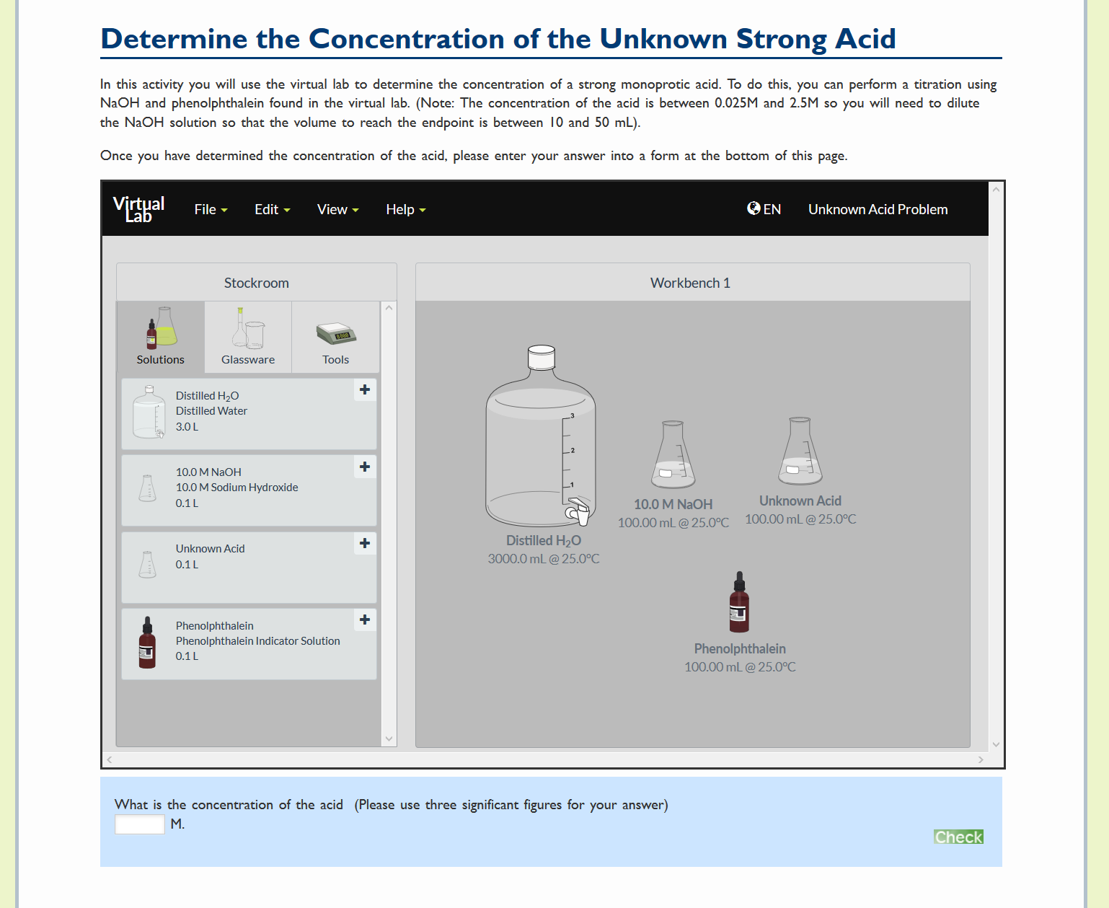

Figure 2.3 Conduction of a Concentration Experiment (Yaron, Karabinos, Lange, Greeno, & Leinhardt, 2010)

### 2.3.3 Virtual Chemistry Lab Technology

Virtual Lab is an application based simulation system that is available for Microsoft’s Windows and Apple’s Mac OS X. It includes lab experiments which are accomplished through the use of real-time 3D graphics and pre-rendered animation. It requires Windows 8.1 or an older version whereas on a Mac, it must be powered by version 10.1.5 or newer. It’s free to use. Once a user launches the downloaded program, it automatically brings up the workspace with two options, which are to view the lab or read the experiments. On clicking read experiments, it slowly zooms onto the desk area and brings up four lab experiments one can perform. The ‘view lab’ option allows the user to navigate around the lab and view the entire room.

The downside of this system is that it is lacking in experiments since it does not have a variety but only 4 lab experiments. It is also difficult to use as chemicals and solutions are not labelled and a development console appears on the left side of the workspace which disrupts the user from working as one has to close it.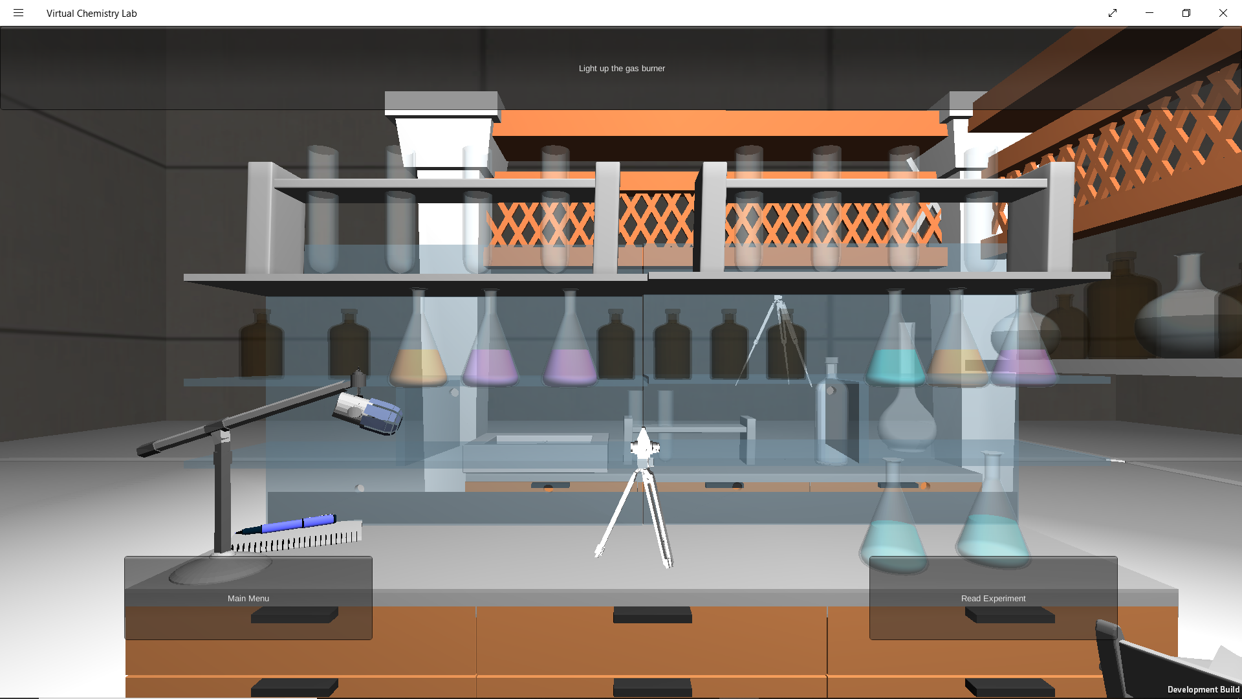

Figure 2.4 View of Lab (MERLOT, n.d.)

## 2.4 Existing Challenges in the use of the current systems

This study investigates the existing challenges associated with the use of the current virtual labs to teach students. The current web-based simulation of lab experiments have technological problems that plague any web site. They rely on servers that are not always in service. Updates of server or browser software may put earlier versions of virtual lab software out of commission. Students require adequate bandwidth to access the most interactive virtual labs, and home modems may not be adequate.

The current Chemistry simulation applications that are offered by several Organizations have a low level of interactivity. They enhance the user experience using good images. However, very few applications encourage user activity. Most of the platforms adapt a common method of providing the necessary chemicals and equipment required to perform an experiment but are not user-friendly in that one does not know how to go about conducting the actual experiment e.g. measuring 100ml of a certain liquid.

Some applications provide download links for reference materials and notes, which falls into the category of reading again. They don’t facilitate any insight tools or progress tracking. They don’t facilitate interaction between the educators and the students. The students cannot seek immediate aid or guidance online.

Some virtual labs are difficult to use and therefore require one to view tutorials to get a basic understanding of how to maneuver and manipulate the components within the lab.

There are training issues involved with students using virtual labs without supervision. When virtual labs link to other web sites, these links must be constantly checked for accuracy and continued existence. Web materials become out of date and require updating on a regular basis.

The huge amount of material on the web is daunting to many students and requires a critical eye to distinguish accurate from inaccurate web sites (MaKinster, Beghetto, & Plucker, 2002)

## 2.5 Gaps in the existing systems

Simulation of lab experiments have the potential to revolutionize the teaching of subjects, but gaps in its recognized potential and the actual applications still exist (Piccoli, Ahmad, & Ives, 2001). Most virtual labs are not designed and implemented correctly leading to over-simplifying and disregarding of health and safety in the lab environment. Health and safety education is particularly important in secondary level education and in the courses of higher level education that require lab experimentation, as this sets the ground for any future lab work the students might take part in. Ignorance in the health sector, may lead to serious injuries when a student for example, mixes in different quantities two toxic Chemistry solutions together in the lab whereas in the virtual environment it did not alert of any problems.

Virtual labs also generate data, which relies on the underlying assumptions, thus lacking the level of natural variation, and therefore students do not become familiar with poor or uncharacteristic data, nor will they learn how to deal with issues rising from these types of data such as mixing of high quantities of solutions leading to the creation of toxic gases.

## 2.6 Conceptual Framework

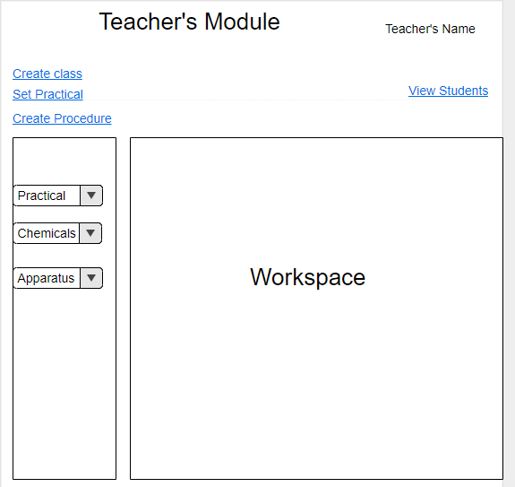

Figure 2.5 Teacher’s Module Framework

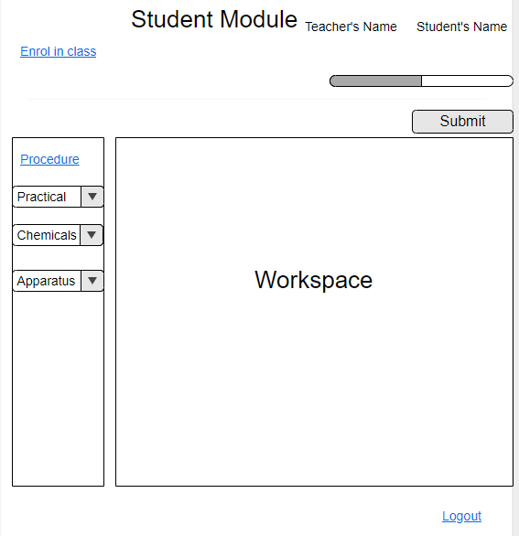

Figure 2.6 Student’s Module Framework

All students will get an equal chance to perform experiments even beyond the classroom level. The student will be able to select the most convenient time to practice performing the practicals. The learning process will also be made enjoyable since the classroom monotony will be eliminated.

All the lab chemicals and equipment will also be provided in the web application hence eliminating the burden of purchasing them from schools.

The teaching experience of the teachers will also improve by allowing more time for lower level interaction with their students. Teachers will monitor the performance of their students and be able to identify the ones who require extra assistance in performing the practicals.

# Chapter 3: Development Methodology

## 3.1 Introduction

This chapter discusses the software development methodology to be used in the proposed project. It also highlights the system analysis and design approaches used. Finally, the chapter gives a description of the tools and techniques to be used in the project.

## 3.2 Software Development Methodology

This system puts into use the prototype model. The Prototyping Model is a Systems Development Methodology (SDM) within which a paradigm output (or an early approximation of a final system or product) is constructed, tested, and then reworked. It is done until an appropriate paradigm is achieved to help develop the entire system or product (Ganpatrao Sabale, 2012) . This model was chosen because it will require to have a lot of interaction with the end users. Prototyping will ensure that the users constantly work with the system and provide feedback which is incorporated in the prototype to result in a useable system. The final product is more likely to satisfy the user’s desire for look, feel and performance.

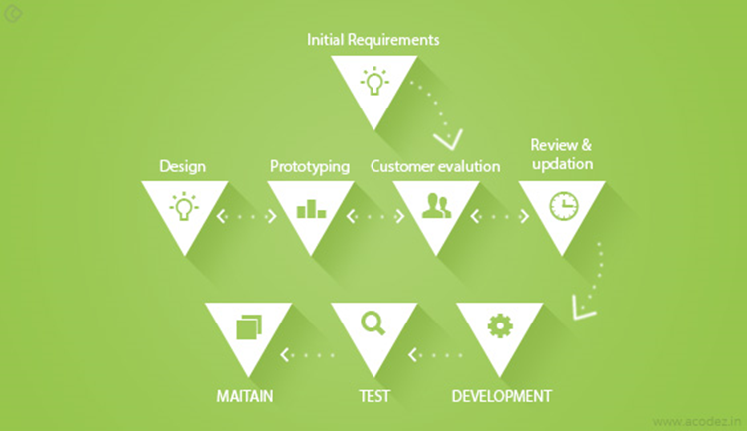

Figure 3.1 Prototyping Model (Mishra & Dubey, 2013)

The first stage in prototyping is determining the system requirements and its major components. The main goal of this project is to enhance the learning process in Chemistry practicals specifically for high school students.

The second stage involves the evaluation of customers who will use the system. The main customers of this system are high school teachers and students. The students need the system to facilitate their learning of Chemistry practicals while teachers use the system to monitor the progress of their students in performing the practicals.

The third stage entails the designing of the system. A preliminary design of the system is sketched on paper and its functionalities are discussed with the stakeholders in order to improve the system.

In the fourth stage the design of the system is reviewed to evaluate whether it meets all the required functionalities.

In the fifth stage, the system is developed and all its proposed functionalities are implemented. The refinement process is repeated until the system meets all the requirements as stated by the stakeholders.

In the sixth stage the developed system is tested by being made available to the stakeholders. They evaluate the system to see whether it meets the requirements that they had stated.

In the final stage, the developed system is deployed for use. The system maintainers constantly improve the system and troubleshoot it for any errors.

## 3.3 System Analysis

System analysis is a technique that breaks down a system into its component pieces for the purpose of the studying how well those component parts work and interact to accomplish their purpose (Bentley, 2007).

### 3.3.1 Functional requirements

Functional requirements specifies a function that a system or system component must be able to perform (Loucopoulos & Karakostas, 1995).

1. A student should be able to enroll into a certain class with an auto-generated enrolment key
2. A student should be able to conduct an experiment
3. A student should be able to submit the exercise done
4. A teacher should be able to set up laboratory requirements
5. A teacher should be able to grade submitted exercises
6. A teacher should be able to assist a student who’s facing difficulty in conducting an experiment
7. A teacher should be able to view the progress of the students in class in terms of percentage of tasks completed and intervene accordingly

### 3.3.2 Non-Functional requirements

Non-functional requirements (NFR) describe important constraints upon the development and behavior of a software system. They specify a broad range of qualities such as security, performance, availability, extensibility, and portability (Chung, Nixon, Yu, & Mylopoulos, 2012).

For the performance, the load time will be no more than 30 seconds for users accessing the website using a strong network connection. The database update process will roll back all related updates when any update fails. The system will be easy to use for both novices and users with experience from similar systems. The ability to easily manipulate the parameters in an experiment is an essential feature of the simulation environment. The concept of a lab table makes it possible to experiment freely with an object and it provides a simple method for saving results e.g. a titration experiment which requires a maximum of 3 values to be recorded.

### 3.3.3 System Narrative

Upon accessing the system, the student will login and will be presented with a dashboard which they can either to perform the practical on their own or enrol into a classroom generated by their teacher using an enrolment key. The student can select the set of experiment which they wish to perform and monitor their performance in the experiment. After enrolling to a class, the student will view the tasks assigned by the teacher and submit.

The teacher will also login into the system and be able to create a class and generate the enrolment key to be used by the student to access the virtual classroom. The teacher can set the practicals and view the submissions of their students. The teacher can then evaluate the submissions and send the results back to the students.

## 3.4 System Design

Systems design is defined as those tasks that focus on the specification of a detailed computer-based solution. Thus, whereas systems analysis emphasized on the business problem, systems design focuses on the technical or implementation concerns of the system (Bentley, Dittman, & Whitten, 2000)

### 3.4.1 Use Case Diagram

A Use case diagram is used to analyze the interaction between a system and end users (Kawabata, Kasahara, & Itoh, 2007).

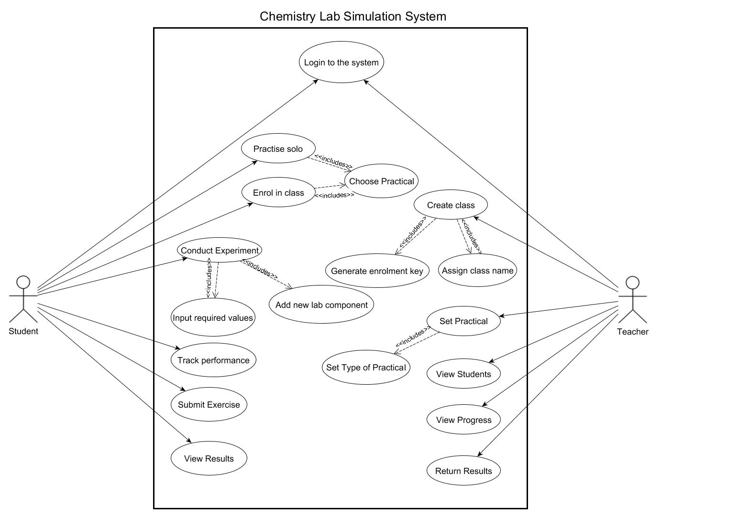

Figure 3.2 Use Case Diagram

### 3.4.2 DFD (Up to level 1)

The data flow diagrams have been extensively used over the years to graphically model out the data transformation and transfer aspects of proposed systems and show briefly how it is expected to handle data.(Ward, 1986)

**Context Level Diagram**



Figure 3.3 Context Level Diagram

**Data Flow Diagram**



Figure 3.4 Data Flow Diagram

### 3.4.3 Entity Relationship Diagram

An entity relationship diagram also known as an ERD or E-R diagram, is a methodology that describes how the data of a system is stored at a high level of detail (Frantiska, 2018)

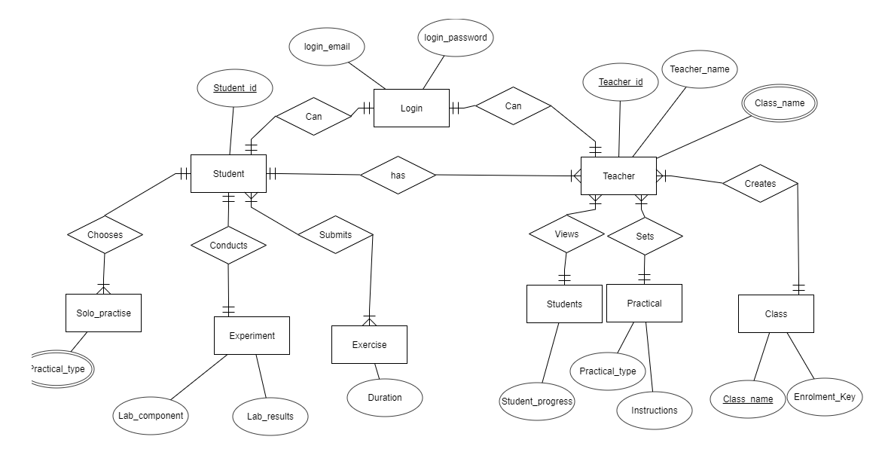

Figure 3.5 Entity Relationship Diagram

### 3.4.4 Database Schema

It is a database approach is that allows a non-redundant, unified representation of all data managed in a database to be graphically represented.(Batini, Lenzerini, & Navathe, 1986)

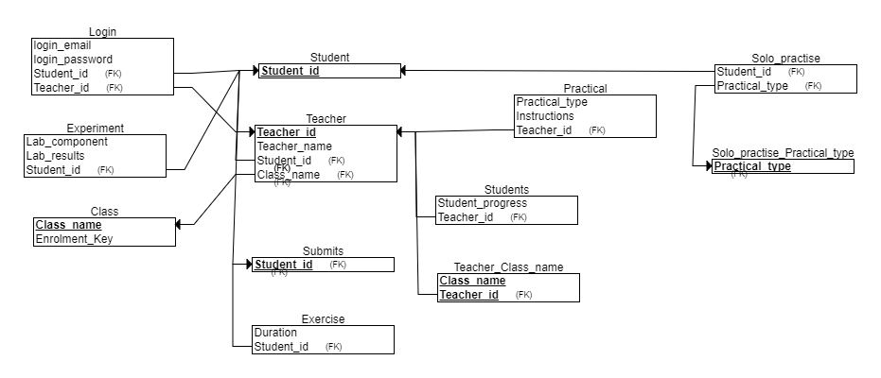

Figure 3.6 Database Schema

## 3.5 System Development Tools and Techniques

### 3.5.1 Visual Studio Code

Visual studio code will be the main development environment used to build the system. All the code will be written and tested using the text editor.

### 3.5.2 JavaScript

Java script is the main scripting programming language used to process the major functionalities used within the web application.

### 3.5.3 HTML

The standard mark-up language used to develop the web pages will be HTML5.

### 3.5.4 CSS

CSS will be used to style all the web pages and provide an appealing interface to the users of the web application.

### 3.5.5 PHP

PHP will be used to handle all the server-side scripts and processes that link the web application to a server and database.

### 3.5.6 Bootstrap

Bootstrap will be used as a framework to develop the main dashboards.

## 3.6 Deliverables

### 3.6.1 Student’s Module

The student shall login to the system and will choose to either perform an experiment alone or to join a class using a code. In the class, the student can view the tasks assigned by the tutor.

### 3.6.2 Teacher’s Module

A teacher will use the system to create lab experiments and assign tasks to students. The teacher will also monitor the progress of the students in performing the assigned tasks.

# References

Batini, C., Lenzerini, M., & Navathe, S. B. (1986). A comparative analysis of methodologies for database schema integration. *ACM Computing Surveys (CSUR)*, *18*(4), 323–364.

Bentley, L. D. (2007). *Systems Analysis and Design for the Global Enterprise* (7th edition). Boston: Irwin/McGraw-Hill.

Bentley, L. D., Dittman, K. C., & Whitten, J. L. (2000). *Systems analysis and design methods*. Irwin/McGraw Hill.

Bristol, J. (2016, November 9). PhET Interactive Science and Math Simulations, Now in App Form! Retrieved August 29, 2018, from https://geekdad.com/2016/11/phet-interactive-app/

Carnevale, D. (2003). The virtual lab experiment. *Chronicle of Higher Education*, *49*(21), A30.

Chung, L., Nixon, B. A., Yu, E., & Mylopoulos, J. (2012). *Non-Functional Requirements in Software Engineering*. Springer Science & Business Media.

Corter, J. E., Nickerson, J. V., Esche, S. K., & Chassapis, C. (2004). Remote versus hands-on labs: A comparative study. In *Frontiers in Education, 2004. FIE 2004. 34th Annual* (pp. F1G–17). IEEE.

De Jong, T., Linn, M. C., & Zacharia, Z. C. (2013). Physical and virtual laboratories in science and engineering education. *Science*, *340*(6130), 305–308.

Frantiska, J. (2018). Entity-Relationship Diagrams. In *Visualization Tools for Learning Environment Development* (pp. 21–30). Springer.

Ganpatrao Sabale, R. (2012). Comparative Study of Prototype Model For Software Engineering With System Development Life Cycle. *IOSR Journal of Engineering*, *02*(07), 21–24. https://doi.org/10.9790/3021-02722124

Gomes, L., & Bogosyan, S. (2009). Current trends in remote laboratories. *IEEE Trans. Industrial Electronics*, *56*(12), 4744–4756.

Josephsen, J., & Kristensen, A. K. (2006). Simulation of laboratory assignments to support students’ learning of introductory inorganic chemistry. *Chemistry Education Research and Practice*, *7*(4), 266–279.

Kawabata, R., Kasahara, T., & Itoh, K. (2007). Systems Analysis for Collaborative System by Use Case Diagram. *Journal of Integrated Design and Process Science*, *11*(1), 13–27.

Kennepohl, D. K. (2001). Using computer simulations to supplement teaching laboratories in chemistry for distance delivery.

Loucopoulos, P., & Karakostas, V. (1995). *System Requirements Engineering*. New York, NY, USA: McGraw-Hill, Inc.

MaKinster, J. G., Beghetto, R. A., & Plucker, J. A. (2002). Why Can’t I Find Newton’s Third Law? Case Studies of Students’ Use of the Web as a Science Resource. *Journal of Science Education and Technology*, *11*(2), 155–172. https://doi.org/10.1023/A:1014617530297

MERLOT. (n.d.). Virtual Chemistry Laboratory. Retrieved August 30, 2018, from https://www.merlot.org/merlot/viewMaterial.htm?id=89055

Mishra, A., & Dubey, D. (2013). A comparative study of different software development life cycle models in different scenarios. *International Journal*, *1*(5), 64–69.

Nedic, Z., Machotka, J., & Nafalski, A. (2003). *Remote laboratories versus virtual and real laboratories* (Vol. 1). IEEE.

Oloruntegbe, K. O., & Alam, G. M. (2010). Evaluation of 3d environments and virtual realities in science teaching and learning: The need to go beyond perception referents. *Scientific Research and Essays*, *5*(9), 948–954.

Omilani Nathaniel, A., Rose, O. N. M., & Abubakar, A. S. (n.d.). The Effect of Combined Virtual and Real Laboratories on Students’ Achievement in Practical Chemistry.

Piccoli, G., Ahmad, R., & Ives, B. (2001). Web-Based Virtual Learning Environments: A Research Framework and a Preliminary Assessment of Effectiveness in Basic IT Skills Training. *MIS Quarterly*, *25*(4), 401–426. https://doi.org/10.2307/3250989

Radhamani, R., Sasidharakurup, H., Sujatha, G., Nair, B., Achuthan, K., & Diwakar, S. (2014). Virtual labs improve student’s performance in a classroom. In *International Conference on E-Learning, E-Education, and Online Training* (pp. 138–146). Springer.

Tüysüz, C. (2010). The Effect of the Virtual Laboratory on Students’ Achievement and Attitude in Chemistry. *International Online Journal of Educational Sciences*, *2*(1).

Ward, P. T. (1986). The transformation schema: An extension of the data flow diagram to represent control and timing. *IEEE Transactions on Software Engineering*, (2), 198–210.

Wieman, C. E., Adams, W. K., & Perkins, K. K. (2008). PhET: Simulations that enhance learning. *Science*, *322*(5902), 682–683.

Yaron, D., Karabinos, M., Lange, D., Greeno, J. G., & Leinhardt, G. (2010). The ChemCollective—virtual labs for introductory chemistry courses. *Science*, *328*(5978), 584–585.

# Appendices

## Appendix A: GANTT Chart

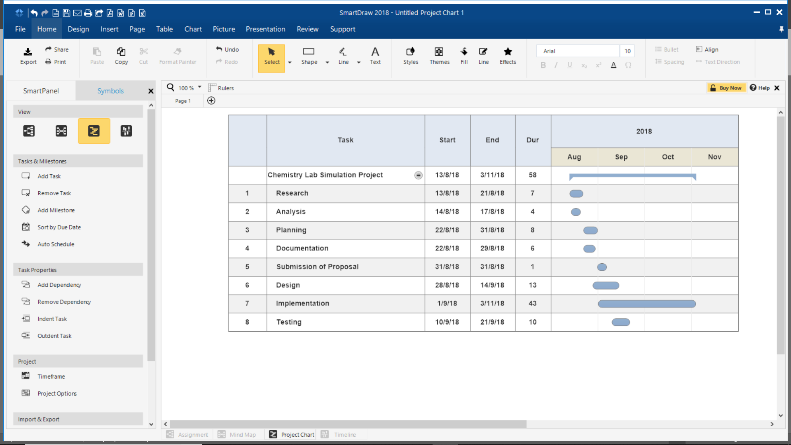*Table 1 Project Timeline*